December 2021
Dear Friends,
HAPPY HOLIDAYS!!!
I sincerely hope that as the holidays approach, you and your family are well, and that you have the time to find some peace and simple joy during the holiday season. I start this letter (as usual) with a favorite quote:
“The best and most beautiful things in the world cannot be seen or even touched-they must be felt with the heart.”-Helen Keller
I think this applies to so many of us in ways we may not even be aware of. How often do you find yourself following your instincts or “going with your gut”? We don’t need to see the light in a loved one’s eyes or even physically touch them to feel loved. Speaking for myself, I feel real joy coming from the individuals we serve at being able to emerge from pandemic isolation and be together with their peers, staff, and families. I feel genuine affection coming from the staff as they interact with the individuals in the most patient and caring of ways. I feel thankful to be a part of this world; a world where people genuinely care about and support each other…the world of the GEC.
I would like to share some recent news with you:
GEC OPENS NEW DAY PROGRAM CENTER
One of the positive things that came out of the pandemic was the development of new program space for the GEC. With our Fischetti Center in Marine Park temporarily closed we began to search for an appropriate space for some of our day habilitation programs to resume in person services. The Knights of Columbus (KOC) John Hughes Council provided an opportunity. A large, open space with parking, run by KOC staff that already have a warm relationship with the GEC, it had all the makings of an excellent space for our individuals. We added a state-of-the-art fire alarm/carbon monoxide detection system, along with some furniture, computers, tablets, exercise and activity equipment. Dyker Park is right across the street and in good weather, provides a great space for outdoor activities as well. The Fischetti Center and Without Walls program participants are currently sharing the space at the Knights and program opportunities are expanding, as staff incorporate different volunteers and “experts” to run exercise groups, arts and crafts, music, and recreation. Here are a few comments from the individuals attending program at KOC about the new space:
- Herone: “I adjusted well with attending the Knights of Columbus. It is nice to be back with everyone. I enjoy making products with the Cricut machine.”
- Elizabeth:” I love being with my friends & staff. Tuesdays are fun when we play sports!”
- Camila: “The space at the Knights of Columbus is nice & big. It is great to be back with everyone.”
- Brian: “I like it here at the Knights of Columbus because I can see my friends & staff again.”

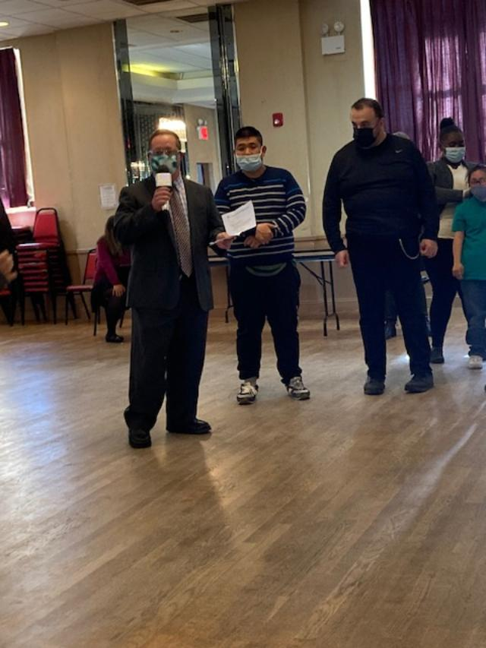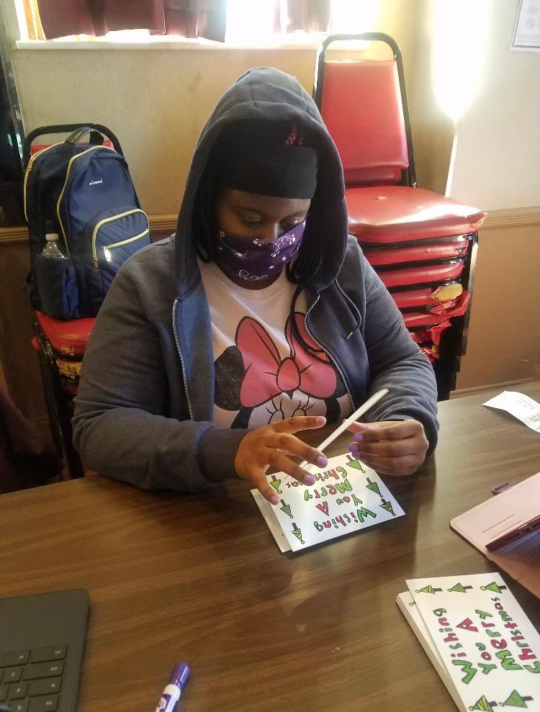
- Kaitlyn: “I love it here at the Knights of Columbus. We have the opportunity to exercise & participate in fun activities.”
- Phillip: “I love the Guild & The Knights of Columbus. I am happy here & enjoy working on my math.”
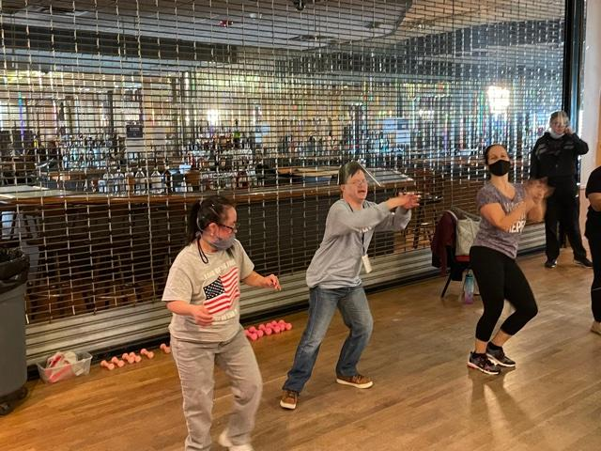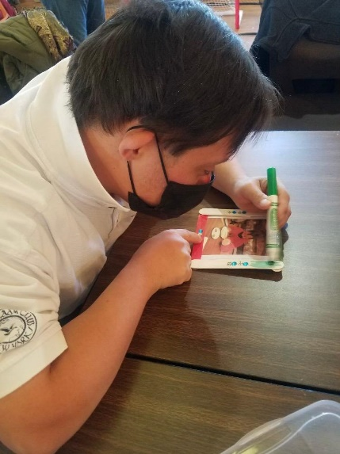
Several neighborhood worksites have expressed interest in re-opening to GEC involvement and we have been slowly building transportation services back up. Thank you for the support you have provided and continue to provide, that enable us to make this happen.
BEST FRIENDS FIND NEW HOMES WITH GEC
Mary lived most of her life with her mother. When her mother passed away some years ago, Mary was already a senior citizen and attended the Four Season’s Day Program at GEC. She wanted to try living independently with supports. Her best friend Maureen, also attending Four Seasons, moved in with her and GEC provided Residential Habilitation in their home. As the years went by, age related health issues combined with their disabilities made it more difficult for Mary and Maureen to be on their own. GEC had residential openings in 2 of our Individualized Residential Alternatives (IRA’s) and after a number of visits Maureen and Mary decided to move in; Mary to Santangelo Residence and Maureen to Olga’s House. Both are very happy with their new homes and remain best friends who see each other every day at the Four Seasons. According to Maureen, she is “very happy with my new house, and the staff is great!”
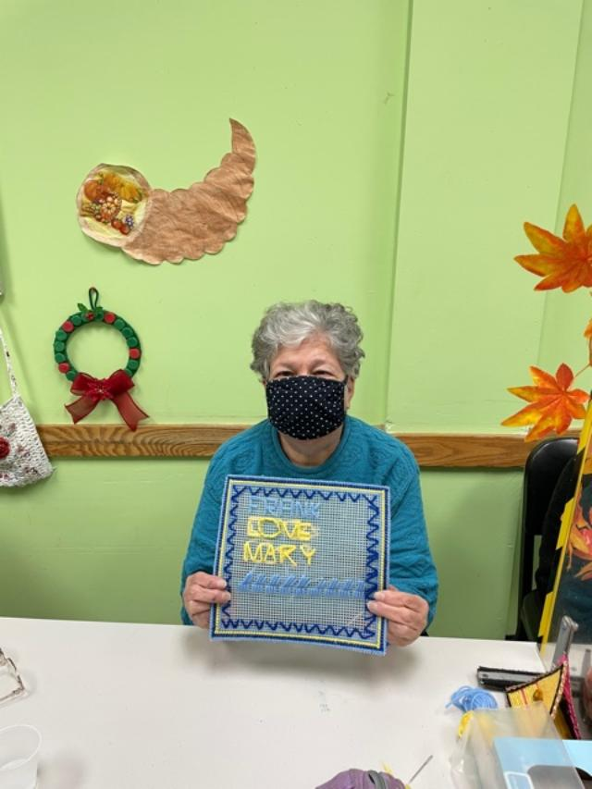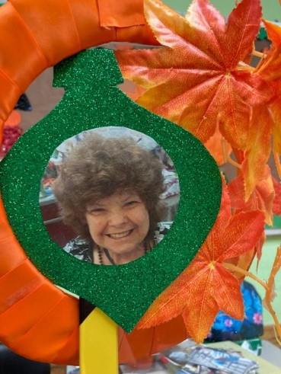
FACING SOME BIG CHALLENGES
When caring for vulnerable people, there is always a balancing act that must be performed between keeping people safe, and giving them opportunities to socialize, meet new people, and experience new things. The pandemic has made this balancing act even trickier, and the ever-changing status of infection rates and variants blur the lines between what is a reasonable precaution, and what is paranoia. The more that we can do with mask wearing, sanitizing, air filtration, outdoor activities, and social distancing (for now) the safer we can be. These measures are costly. Social distancing requires more space and more staffing for smaller groups, PPE (Personal Protection Equipment) is costly when used every day.
Another challenge we face is related to our IT infrastructure (computer systems and wireless technology). During the pandemic, many companies have used the time to upgrade their computer networks. At the same time, unscrupulous parties have found newer, more insidious ways to infiltrate computer networks and steal someone’s private information, or initiate ransomware or malware attacks. At GEC our IT infrastructure is aging, and even though we are required to file more of our reports electronically to satisfy regulations, we are not provided with government support for IT upgrades. Money is sorely needed to make our network and devices safe for the individuals and staff to use.
Providing desperately needed education and supports to children with disabilities and their families has become more difficult in recent years. Government support is uneven, allocating per child a fraction of the funding it provides to typically functioning children in public schools, even though special education teachers and therapists must have the same certifications and qualifications as their regular education counterparts. It is discriminatory and deplorable. GEC is always looking for ways to supplement the costs of running our wonderful school for young children with special needs; a school that has helped so many families get a good start on helping their children to lead full and satisfying lives.
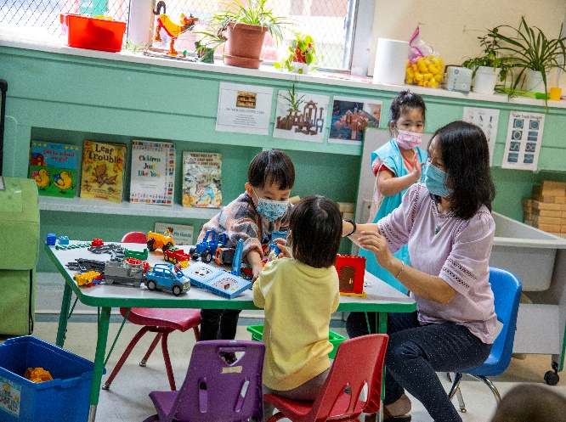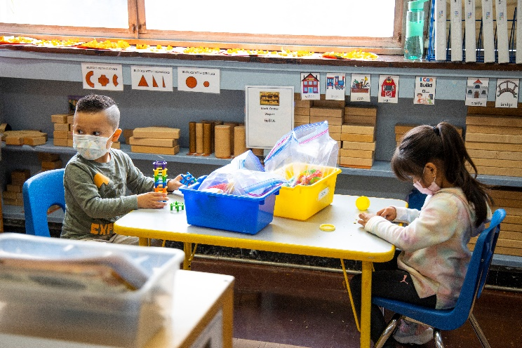
Finally, GEC, like so many other providers across NY State and the US, are in the middle of the worst workforce crisis in history. Certainly, in my 35 years with GEC I have not seen anything like it. In Florida last week, five group homes suddenly closed because they were unable to find staffing. Individuals were found roaming the streets, homeless. This is a horrible, cautionary tale. The Direct Support Professionals (DSP’s) who work hands on with developmentally disabled people are underpaid for the work that they do. Government funding currently allows for a salary near minimum wage for DSPs. GEC is working tirelessly, along with hundreds of other agencies, to advocate for better salary related funding for DSPs. In the meantime, we have become creative in fundraising that would directly benefit DSPs in the form of longevity and retention bonuses. It may not be enough to raise their hourly salary, but it lets the DSPs know that their dedication and diligence are appreciated. Much of our fundraising today is focused on incentivizing the workforce.
A HOLIDAY MESSAGE
We have been living through unprecedented times during the last 2 years; divisiveness, isolation, and the most devastating plague of our lifetime. Never has compassion been more important than it is today. The past two years have given people a chance to examine their life choices, to consider how they choose to spend their lives. Did I make the right choices in life? Am I living a good life? Since the holidays are approaching, I will enlist the help of Charles Dickens to attempt to answer those soul-searching questions. In Dickens’ a Christmas Carol there is a scene in which Scrooge is confronted by the ghost of his former partner, Jacob Marley. Marley says that “No amount of eternal regret can make up for a life’s opportunities misused” and goes on to tell him about the heavy chain he has forged for every self-serving decision he made. “But you were always a good man of business!” Scrooge replied. But then Marley wails “Mankind was my business, the common welfare was my business, charity, mercy, forbearance, benevolence were all my business! The workings of my counting house were but a drop in the comprehensive ocean of my business!”
At GEC humankind is our business. We are fortunate to have friends and supporters like you who hold the same values.
So, as we enter into the Holiday season trying to struggle through the isolation the pandemic has left us with, I am asking you to make charity, mercy, and benevolence part of your business! Please continue to support the GEC in any way you can as we continue our 63-year legacy of Building Better Lives for People with Developmental Disabilities, and may you all have a healthy, safe, and happy Holiday Season. In the words of Tiny Tim “May God bless us, everyone!”
Sincerely,

Joseph L. Riley
CEO/Executive Director

